***DESCRIPTION***

***Background***

E-commerce is fast gaining ground as an accepted and used business paradigm. More and more business houses are implementing web sites providing functionality for performing commercial transactions over the web. It is reasonable to say that the process of shopping on the web is becoming commonplace.

***Objective***

An Online E-Commerce Company wants to design a Sales dashboard to analyze the sales based on various product categories. The company wants to add user control for product category, so users can select a category and can see the trend month-wise and product-wise accordingly.

Domain: E-Commerce

Dataset Description

We will be using E-Commerce Dashboard.xlsx Dataset [here.](https://www.dropbox.com/s/c630y2ewbymlbum/BA%20with%20Excel.zip?dl=0&file_subpath=%2FBA%2Bwith%2BExcel)

* **E-Commerce Dashboard which covers Orders data for various Product Category;**

Within this file you will find the following fields:

|  |  |
| --- | --- |
| **Field** | **Description** |
| Order ID | Unique Order ID of a product |
| Order Date | Order Placement Date |
| Ship Date | Shipment Date of the placed order |
| Aging | Used to Create Histogram Bin |
| Ship Mode | Shipment mode of placed order |
| Product Category | Product Category |
| Product | Name of the Product |
| Sales | Sales Amount |
| Quantity | The amount or number of a material |
| Discount | A deduction from the usual cost of something |
| Profit | Obtain a financial advantage or benefit |

|  |  |
| --- | --- |
| Shipping Cost | The amount required to ship the placed order |
| Order Priority | Precedence of placed order |
| Customer Id | Unique Customer ID |
| Customer Name | Name of the Customer |
| Segment | ProductSegment(i.e.Home Office/Corporate/Consumer etc.) |
| City | Unique City Name |
| State | Unique State Name |
| Country | Unique Country Name |
| Region | Especially the part of a country |
| Months | The month of placing the order |

Analysis Tasks

* + Use the Saved Sample – E-Commerce database.
  + Create a histogram to analyse a number of shipping days.

•

Hints Steps Utilised :

Sample Step Create Histogram for Shipping Days(Aging)

To create a histogram, click the Data Tab, Under Analysis Group (Right Corner), Click Data Analysis. Now, select Histogram and click ok. A histogram dialog box will appear.

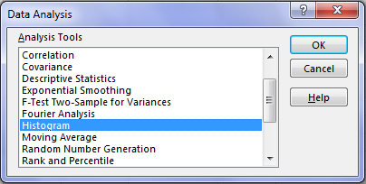

In the histogram dialog box, first, click the Label’s Checkbox as we have labels in our data. After that, In the **Input reference box** select the range **(“Sales Data!D1: D51291”)** of our data and in the **Bin Range Reference box** select **(“Working!K3: K7”)**.In the **Output section**, select range “Working!N3” for a binning table, click Histogram checkbox and then ok.

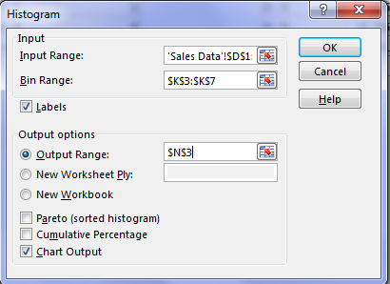

Created Histogram Using Above mentioned Steps below :

**Maximum of Each bin**

More

10

9

5

1

0

Frequency

20000

10000

**Histogram**

30000

**Frequency**

* + Prepare a table of Sales and Profit month-wise in one sheet, named it as ‘Working Sheet’.

Second Table is linked with comb box and made by inserting pivot table using sales table data by dragging appropriate data into various columns.

Code Used :

Sales = OFFSET(R15,ROW()-34,F140) Profit = OFFSET(Z15,ROW()-34,F140)

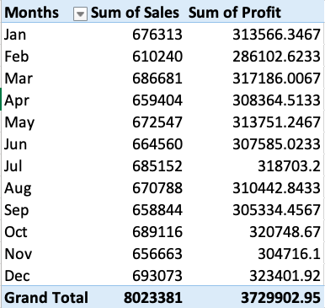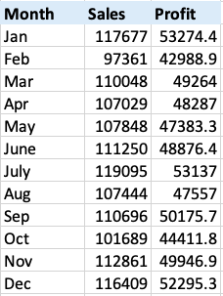

* + Prepare the sales table region-wise in the working sheet. Code Used :

Sales = OFFSET(AK42,ROW()-42,F140) and later linked with combo box

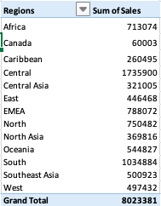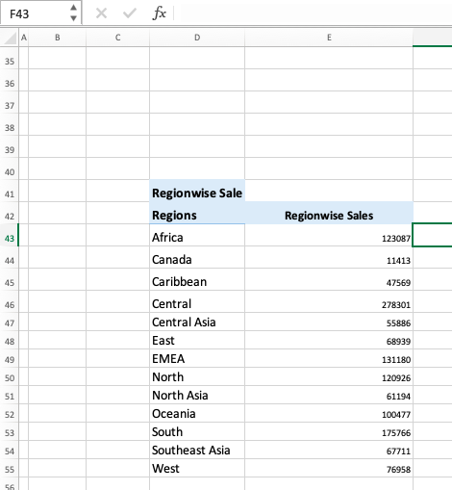

* + Create a User Control Combo box for Product Category.

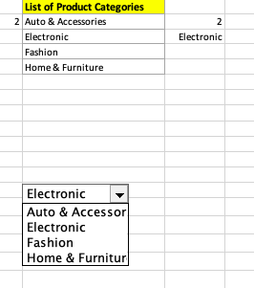

Code Used :

Electronic Box Shown above values gets populated accordingly as 1,2,3,4 respectively from various categories as shown above =OFFSET(L33,F140,0)

* + Create Column Chart of a month-wise table and region-wise table

# Steps Followed :

Select the column pertaining to month wise sales and profit and region wise sales and then click on Insert -> Data -> Chart and click on clustered 2D Chart to get output as below.

Next Right Click on Chart and format it as per requirements by clicking format fields and axis



**Region Wise Sales**

2000000

1500000

1000000

500000

0

Total

800000

600000

400000

200000

0

Jan Feb Mar Apr May Jun Jul Aug Sep Oct Nov Dec Sum of Sales Sum of Profit

* + Link the table with combo box.

Code Used : Using SUMIFS function and pulling data from sales table

Sales Box Value = SUMIFS('Sales Data'!$H:$H,'Sales Data'!$F:$F,Working!$F$141) Quantity Box Value =SUMIFS('Sales Data'!$I:$I,'Sales Data'!$F:$F,Working!$F$141) Profit Box Value = SUMIFS('Sales Data'!$K:$K,'Sales Data'!$F:$F,Working!F141)

* + Create a dashboard.

Created as per requirements meticulously designed and it matches with the sample output.

# Created As shown Below : Auto & Accecorries

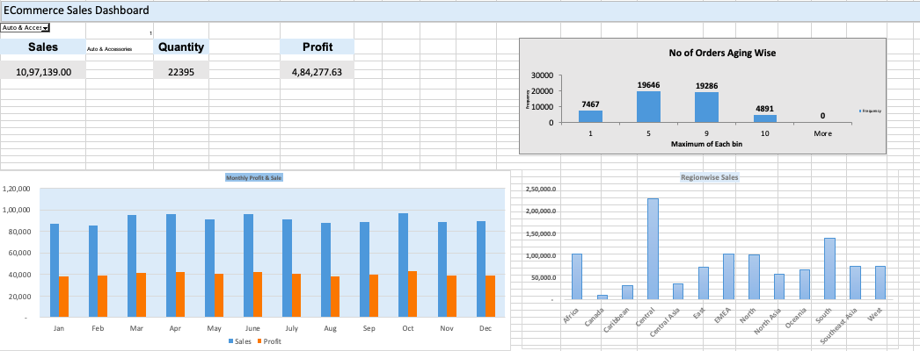

**Home & Furniture**

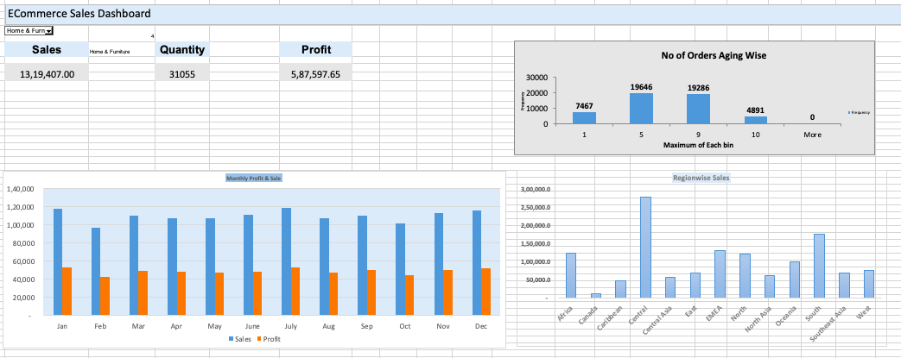

**Electronics**

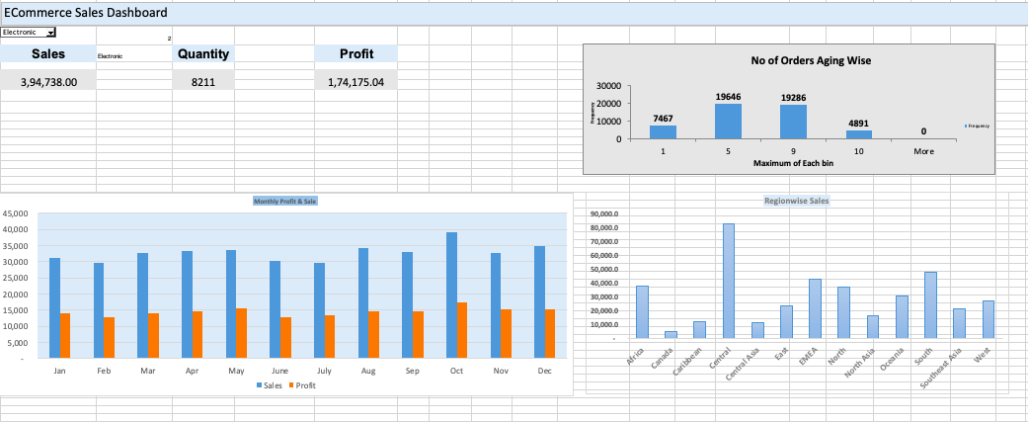

**Fashion**

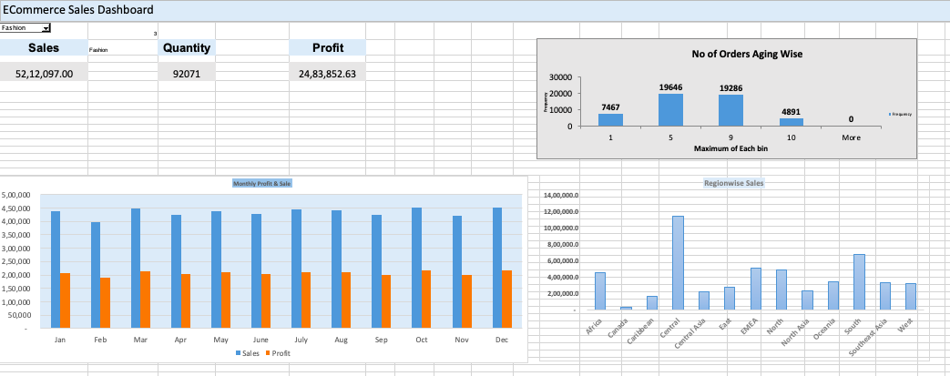

**Sample Output :**

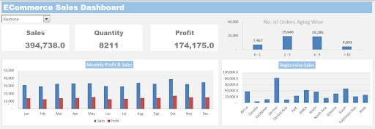

Note: Sample output is given, please make it a meticulous as per the project statement.

# Below I have attached my excel sheet too where I have done all the workings and created a dashboard too with all the tables shown as per requirements.



Business Analytics With Excel

**Frequency**

**Africa**

**Canada**

**Caribbean**

**Central**

**Central Asia**

**East**

**EMEA**

**North**

**North Asia**

**Oceania**

**South**

**Southeast Asia**

**West**

**E-Commerce Sales Dashboard**



**Months Sales Profit**

**Regions**

Africa Canada Caribbean Central Central Asia East

EMEA

North North Asia Oceania

South Southeast Asia West

**Sales**

Bins Maximum of Each bin

*Maximum of Each bin Frequency*

Jan

Feb Mar Apr May Jun Jul Aug Sep Oct

Nov Dec

4,39,830

3,97,420

4,48,584

4,22,996

4,39,549

4,26,494

4,44,723

4,41,103

4,25,863

4,50,840

4,22,629

4,52,066

2,07,755

1,91,681

2,12,583

2,03,108

2,09,886

2,03,841

2,11,223

2,10,086

2,00,985

2,15,612

2,00,632

2,16,460

4,49,838.0

33,606.0

1,68,146.0

11,46,920.0

2,17,590.0

2,81,855.0

5,11,418.0

4,92,785.0

2,35,414.0

3,47,144.0

6,72,013.0

3,37,010.0

3,18,358.0

0 - 1

0 - 5

6 - 9

>10

1

5

9

10

1

5

9

10

More

7467

19646

19286

4891

0

**Months Sum of Sales Sum of Profit**

**Regions Sum of Sales**

Jan Feb Mar Apr May

Jun Jul Aug Sep Oct Nov

Dec

676313 313566.3467

610240 286102.6233

686681 317186.0067

659404 308364.5133

672547 313751.2467

664560 307585.0233

685152 318703.2

670788 310442.8433

658844 305334.4567

689116 320748.67

656663 304716.1

693073 323401.92

Africa Canada Caribbean Central Central Asia

East EMEA

North North Asia Oceania

South

713074

60003

260495

1735900

321005

446468

788072

750482

369816

544827

1034884

**Sum of Sales Column Labels**

**Months Auto & Accessories Electronic Fashion Home & Furniture Grand Total**

**Sum of Profit Column Labels**

**Months Auto & Accessories Electronic Fashion Home & Furniture Grand Total**

Jan

Feb Mar Apr

87526 31280 439830

85683 29776 397420

95249 32800 448584

95962 33417 422996

117677 676313

97361 610240

110048 686681

107029 659404

Jan

Feb Mar Apr

38447.32 14089.78 207754.8367 53274.41 313566.3467

38753.1 12679.38333 191681.26 42988.88 286102.6233

41165.32 14173.37333 212583.2733 49264.04 317186.0067

42365.8 14603.29333 203108.44 48286.98 308364.5133

**Months**

Jan Feb Mar Apr May Jun Jul Aug Sep Oct Nov Dec

**Grand Total**

**Sales**

**Profit**

207754.84

191681.26

212583.27

203108.44

209885.79

203840.69

211222.97

210086.00

200984.58

215612.47

200632.06

216460.25

2483852.63

May

91445 33705 439549

107848 672547

May

40871.83 15610.28333 209885.7933 47383.34 313751.2467

439830

397420

448584

422996

439549

426494

444723

441103

425863

450840

422629

452066

5212097

Jun

96597 30219 426494

111250 664560

Jun

42010.25 12857.70333 203840.6867 48876.38333 307585.0233

Jul

91690 29644 444723

119095 685152

Jul

40958.9 13384.33667 211222.9733 53136.99 318703.2

Aug

88153 34088 441103

107444 670788

Aug

38237.91 14561.95 210085.9967 47556.98667 310442.8433

Sep

89216 33069 425863

110696 658844

Sep

39655.96 14518.25667 200984.5833 50175.65667 305334.4567

Southeast Asia 500923

Oct

Nov

97347 39240 450840

88575 32598 422629

101689 689116

112861 656663

Oct

Nov

43305.21 17419.19667 215612.4733 44411.79 320748.67

39016.39 15120.76333 200632.0633 49946.88333 304716.1

**Grand Total 8023381 3729902.95**

West

497432

Dec

89696 34902 452066

116409 693073

Dec

39489.64 15156.72333 216460.25 52295.30667 323401.92

**Grand Total 8023381**

**Grand Total**

**1097139 394738 5212097 1319407 8023381**

**Grand Total**

**484277.63 174175.0433 2483852.63 587597.6467 3729902.95**

**List of Product Categories**

Auto & Accessori

Electronic

3

Fashion

**Month Sales Profit**

Fashion

Home & Furniture

**Regionwise Sale**

**Regions** Africa Canada Caribbean

Central Central Asia East

EMEA

North North Asia Oceania South

Southeast Asia West

**Regionwise Sales**

449838

33606

168146

1146920

217590

281855

511418

Jan

Feb Mar Apr May June July Aug Sep Oct Nov Dec

439830 207755

397420 191681

448584 212583

422996 203108

439549 209886

426494 203841

444723 211223

441103 210086

425863 200985

450840 215612

422629 200632

452066 216460

**Sum of Sales Column Labels**

**Regions Auto & Accessories Electronic Fashion Home & Furniture Grand Total**

492785

235414

347144

672013

337010

318358

Africa

Canada Caribbean

Central Central Asia East

EMEA

North North Asia Oceania South

Southeast Asia West

**Grand Total**

102156 37993 449838

10382 4602 33606

32493 12287 168146

227929 82750 1146920

35956 11573 217590

72321 23353 281855

102947 42527 511418

100025 36746 492785

56978 16230 235414

66631 30575 347144

139614 47491 672013

74598 21604 337010

75109 27007 318358

**1097139 394738 5212097**

123087 713074

11413 60003

47569 260495

278301 1735900

55886 321005

68939 446468

131180 788072

120926 750482

61194 369816

100477 544827

175766 1034884

67711 500923

76958 497432

**1319407 8023381**

ECommerce Sales Dashboard

3

**Sales** Fashion

**Quantity**

**Profit**

**No of Orders Aging Wise**

52,12,097.00

92071

24,83,852.63

30000

20000

10000

0

**19646**

**19286**

**7467**

**4891**

1 5

9 10

**Maximum of Each bin**

**0**

More

Frequency

**Monthly Profit & Sale**

**Regionwise Sales**

5,00,000

4,50,000

4,00,000

3,50,000

3,00,000

2,50,000

2,00,000

1,50,000

1,00,000

50,000

-

**14,00,000.0**

**12,00,000.0**

**10,00,000.0**

**8,00,000.0**

**6,00,000.0**

**4,00,000.0**

**2,00,000.0**

**-**

Jan Feb

Mar Apr May June July Aug

Sales Profit

Sep Oct Nov

Dec